Database Final Report

Artistry Ave

Submitted to

Computer Science Department

College of Computing Sciences and Engineering

Kuwait University

Instructor

Dr. [Maha Alabduljalil](mailto:maha@cs.ku.edu.kw)

Group Members

[Omar Aly] [ 2171122196] {Group Leader}

[Aya Al-Sakkaf] [ 2181156174 ] {Member}

13th January 2022

**Acknowledgements**

Table of contents

Introduction and Background **4**

User and System Requirements **6**

System Architecture **6**

System Design Artifacts **6**

Modifications of the Original Plan (Optional) **6**

Implementation Framework and Details **6**

Testing **7**

Tools and Component Reuse **7**

Conclusions and Lessons Learned **8**

References **8**

Appendices **8**

# Introduction and Background

*An overall description of the project, the motivations behind it, deliverables, and scope of the work.*

How does one define art? For many people, art is a tangible thing: a painting, sculpture, photograph, dance, poem, book, song, or play. As an expressive medium, it allows us to experience wide ranges of emotion, between joy or sorrow, or confusion and clarity. It gives voices to ideas and feelings, connects us to the past, reflects the present and anticipates the future. Webster’s New Collegiate dictionary defines art as “conscious use of skill and creative imagination especially in the production of aesthetic objects''. Yet art is much more than a medium, or words on a page. It is the expression of our experience.

The beauty of art relies on its subjectivity and impact. There are two leading conceptions when it comes to art appreciation. The first, being the most popular, where “To appreciate” means to cherish or like. One philosopher held a version of art appreciation. While he does not explicitly use the word “appreciation”, David Hume, explains that when judging a work of art, what matters is whether we take pleasure from the experience of the works in question. Hume’s judgment of taste is rooted in subjectivity.

Meanwhile, Leo Tolstoy mentions in his book “What is art?” that art cannot be defined as an activity which produces beauty. Beauty cannot be defined objectively, and therefore cannot be used as a criterion to define what is, or is not, art. The aim of art is not merely to produce beauty, or to provide pleasure, enjoyment, or entertainment. Art is a means of communication, and is an important means of expression of any experience, or of any aspect of the human condition.

Tolstoy further explains “The activity of art is based on the fact that a man, receiving through his sense of hearing or sight another man's expression of feeling, is capable of experiencing the emotion which moved the man who expressed it. To take the simplest example; one man laughs, and another who hears becomes merry; or a man weeps, and another who hears feels sorrow. A man is excited or irritated, and another man seeing him comes to a similar state of mind. By his movements or by the sounds of his voice, a man expresses courage and determination or sadness and calmness, and this state of mind passes on to others. A man suffers, expressing his sufferings by groans and spasms, and this suffering transmits itself to other people; a man expresses his feeling of admiration, devotion, fear, respect, or love to certain objects, persons, or phenomena, and others are infected by the same feelings of admiration, devotion, fear, respect, or love to the same objects, persons, and phenomena. “

From Hume to Tolstoy, we can see that they have different approaches on determining what art is and what it is not. But one constant remains, people have a relationship with art.

Tolstoy put it best when he said “Every work of art causes the receiver to enter into a certain kind of relationship both with him who produced, or is producing, the art, and with all those who, simultaneously, previously, or subsequently, receive the same artistic impression”.

This is where Artistry Ave comes into play. Artistry Ave aims to connect people from all sides of the art spectrum, the amateurs, the art lovers, art experts and everyone in between directly to art through providing a platform for art appreciation.

Artistry Ave is an online art museum displaying some of the most beautiful and well loved art pieces throughout history. Allowing people to have a relationship with their favorite artists, their work and their legacy. While also browsing through the various art pieces that are beautifully displayed on the website and learning more on their history, the various artistic movements and art genres.

Artistry Ave also acts as an artistic bookmark, where people can save their favorite art pieces and come back to it from time to time, all while the web application recommends to the people more pieces that they would like.

# User and System Requirements

*A completed set of user and system requirements covering functional and nonfunctional requirements and goals that cover all aspects of the developed product.*

1. Users can sign up and log in using their credentials
2. Users are able to browse through various art pieces and artists
3. Users are able to add art pieces to their dashboard. The dashboard contains all the users’ favorite pieces.
4. Admins can upload art to the platform

# System Architecture

*Models of system architecture with clear semantics that capture the high level design of the system.*

Django is a MVT architecture:

* M stands for models, models describe the data (related to the database).
* V stands for view, views control what users see.
* T stands for template, templates controls how users see our data.

|  |
| --- |

# System Design Artifacts

*All the design decisions and models and artifacts reflecting the requirements and representing the code.*

# Modifications of the Original Plan (Optional)

*In case of change of directions, mention what changes made to the original plan including but not limited to requirements, design, models, schedules, etc.*

The mechanism of storing art documents at first was done through converting the image JPEG to Binary and then storing the binary encoding in the database, and for the retrieval of documents, a template tag function was written to manage the conversion of binary to JPEG and would then be sent to the django template display the art documents.

The following are the libraries responsible for the conversion mechanism:

|  |
| --- |

# Implementation Framework and Details

*Algorithms developed or used, coding decisions made, frameworks and the choice of operating systems, languages, and compilers.*

Django framework is used to construct the components related to the system. Django is a Python-based framework that follows the MVT (Model – View – Template) architectural pattern.

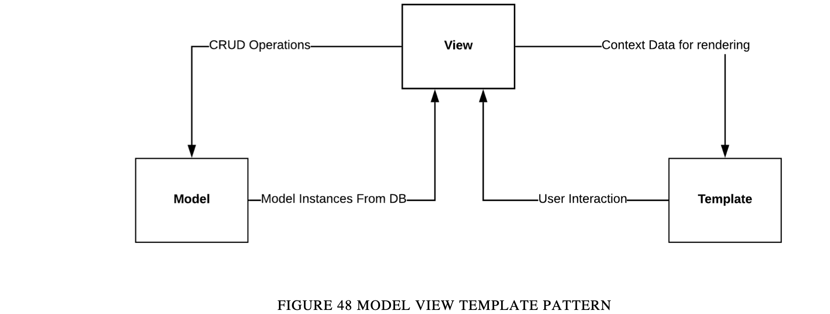

The request starts its life cycle inside the framework by going through the view, where model fetching and business logic will be applied. After applying the logic, the view will return the HTML response that is rendered by the template rendering engine provided by Django.

# Testing

* 1. Testing Plan
  2. Unit Test Cases
  3. Integration Tests
  4. Stress and Performance Tests
  5. Reliability Tests

*A rich documentation of the tests performed. Teams are welcome to add subsections for additional tests(if any).*

# Tools and Component Reuse

*Tools used throughout the project and the benefits of using them. A documentation of all code or design reuse.*

The team used mongoDB cloud to host the database, hosting the database on a cloud offers faster update and seamless accessibility since both team members can make changes to the single version of the database that exists on a cloud, and when the server itself is hosted on a cloud it can easily connect to the hosted database rather than having to set up another database hosting on AWS (where the server instance is to be running).

The team also used AWS’s S3 file storage system. In our project, there needed to be a mechanism to store the art collections. S3 file storage has a flexible mechanism in storing documents of any kind and can then easily be accessed through a URL which we then stored in our Database.

# Conclusions and Lessons Learned

*Final remarks on the project and technical lessons learned.*

To conclude, Artistry Ave offered a platform for everyone on the art spectrum to belong, browsing through different categories of art and exploring your artistic preference along the way. A bookmarking mechanism to store your favourite art to connect more with the art you’ve enjoyed and have them stored somewhere you can easily go back to over time.

The team learned how to manage a NOSQL database, and to adapt to its extensive flexibility in the database structure and the storage of data/documents as opposed to the rigid and strict SQL mechanisms.

# References

*A well-formed list of references according to writing standards.*

[1]

“Django documentation contents | Django documentation | Django,” *Djangoproject.com*, 2022. https://docs.djangoproject.com/en/4.0/contents/‌

[2]

“Welcome to the MongoDB Documentation,” *Mongodb.com*, 2021. https://docs.mongodb.com/ ‌

# Appendices

*Additional material such as screenshots, algorithms, etc.*